Tech-Symposium 2K26

Events
Department of Electrical Engineering

EVENT No. 1 – (E³ Event)
One Day Event on 07/03/2026

- Rules:
Round 1: PDF Mania.
Round 2: Puzzle Bars.
Round 3: Final Round.

- Student Coordinator:
1. Prasad Sawant: 89560 66835
2. Atharv Hedau: 95275 56171

- Location of Event:
EL-1 and EL-2 Classrooms Electrical Engineering Department

- WhatsApp Group:
https://chat.whatsapp.com/D4oeBe4FO4dD9ZAWSg5wKf

- Student QR Code:
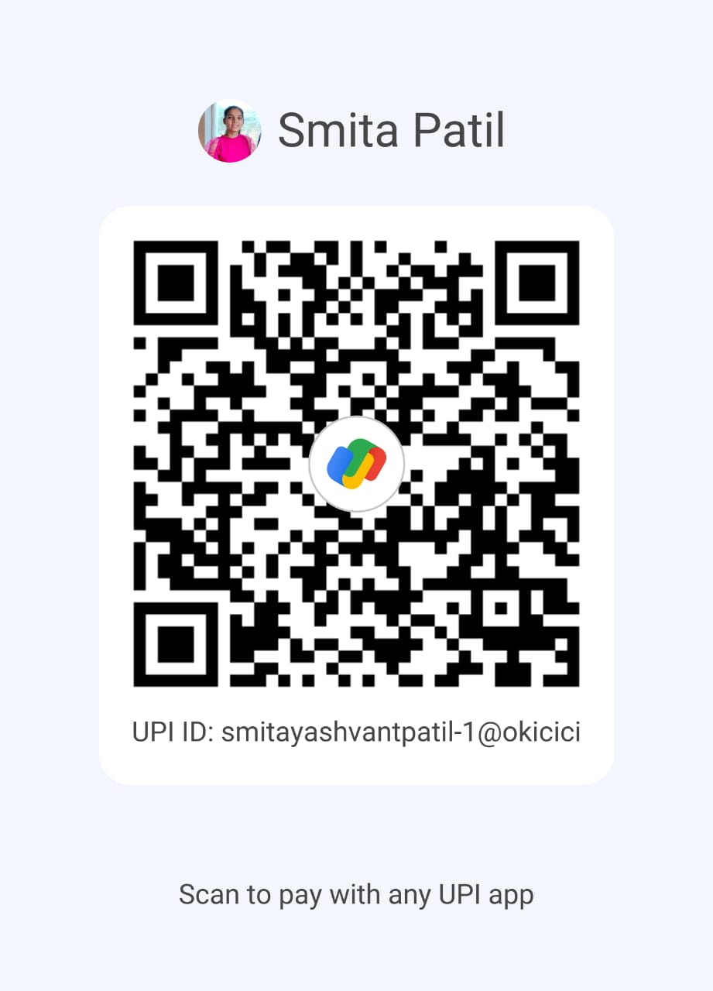

Working Registration Link (mandatory with scanner for payment and what’s app group link inside the form):

